**Tower of Gratitude Show Notes:**

# Acronyms used:

INS = The Immigration and Naturalization Service

EOIR = Executive Office of Immigration Review

BIA = Board of Immigration Appeals

DOJ = Department of Justice

# Artwork used in this episode:

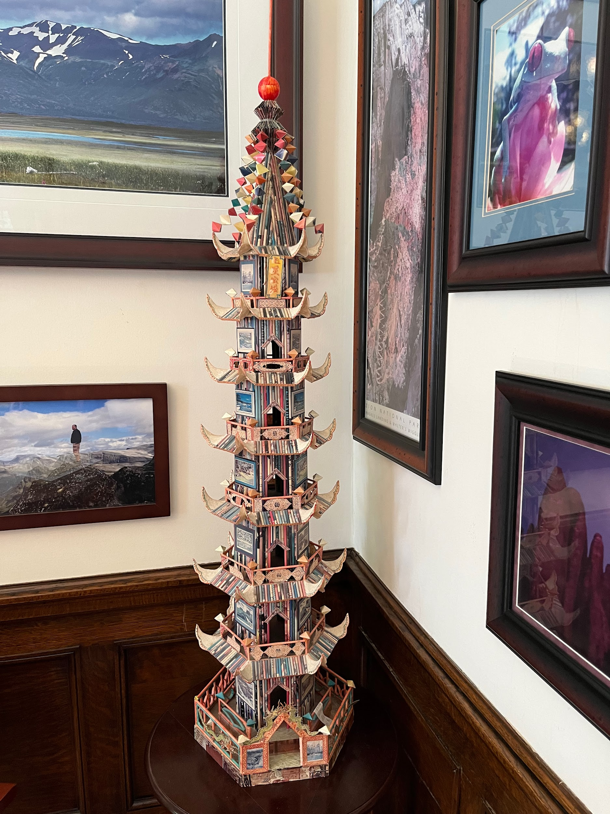

This photo depicts the artwork located in Jeff Lobach’s office that our episode derived its name from. Jeff Lobach referred to this piece as the “Tower of Gratitude.” This art piece was gifted to Lobach by the *Golden Venture* passengers as a personal thank you gift for his extensive legal work on their cases.

Photograph by Benjamin Werkley

Link to a high-quality version of this image: <https://drive.google.com/file/d/18zPv6sGqKvSyDub2IjNWLIuZYQp8ClqD/view?usp=drive_link>

# Further Reading:

For more information about the Snakehead smuggling ring read *The Snakehead: An Epic Tale of the Chinatown Underworld and the American Dream* by Patrick Radden Keefe

Further information about the lawyers that allegedly were retained by the Snakeheads: “Couple Sentenced for Roles In Immigrant Smuggling Ring” by Benjamin Weiser, printed in the *New York Times* on August 10, 2002

# **Sources used in Episode:**

# **Bibliography**

“Asylum Appeal in the Case of [Name Redacted for Attorney Client Privilege],” Decision of the Board of Immigration Appeals, YCPBox#1Doc78 March 22, 1994, In the Class Google Drive in the folder YCP Box #1, Document provided by the York Bar Association.

“Chinese Litigation Update,” Memo from Phyllis Coven to Cliff Sloan and Alan Kreczko, December 16, 1993, YCPBox#1Doc113, located in class shared folder: YCP Box #1, Document provided by the York Bar Association.

Cohn, Peter, dir. 2006. *Golden Venture*. Documentary. Kanopy.

Countess, Frank. 2024. Interview with Frank Countess Interview by Zachary Grossman and Dalton Emig.

“Deposition of James P. Morris,” YCPBox#1Doc188, Located in class shared folder: YCPBox #3, Document provided by the York Bar Association.

“EOIR’s plan to adjudicate Chinese detained cases in New York, Baltimore, and Arlington,” Memo from Gerald Hurwitz to Phyllis Coven, June 8, 1993, YCPBox#1Doc68, Located in shared class folder YCP Box #1, Document provided by the York County Bar Association.

Executive Office of Immigration Review. 2015. “Board of Immigration Appeals.” Www.justice.gov. United States Department of Justice. January 13, 2015. https://www.justice.gov/eoir/board-of-immigration-appeals#:~:text=The%20Board%20of%20Immigration%20Appeals.

Hullinger, Logan. 2019. “Decades after Golden Venture, York County Is an Immigration Detention Hub.” York Dispatch. April 26, 2019. https://www.yorkdispatch.com/story/news/politics/2019/04/26/decades-after-golden-venture-york-county-immigration-detention-hub/3586202002/.

Keefe, Patrick Radden. 2009. *The Snakehead: An Epic Tale of the Chinatown Underworld and the American Dream*. New York: Anchor.

———. 2013. “A Path out of Purgatory.” *The New Yorker*, June 6, 2013. https://www.newyorker.com/news/daily-comment/a-path-out-of-purgatory..

Khong, Crista. n.d. “Shaughnessy v. United States Ex Rel. Mezei.” LII / Legal Information Institute. Cornell Law School. Accessed April 15, 2024. https://www.law.cornell.edu/wex/shaughnessy_v._united_states_ex_rel._mezei.

Legal Information Institute. n.d. “Summary Judgment.” LII / Legal Information Institute. Cornell Law School. Accessed April 3, 2024. https://www.law.cornell.edu/wex/summary_judgment.

Lobach, Jeff. 2024. Interview with Jeff Lobach Interview by Benjamin Werkley and Zachary Grossman.

Maruskin, Joan. Letter to Benjamin Werkley. 2024. “Some Questions about the Golden Venture.” Email, April 13, 2024.

Murray, Margo. 2024. Interview with Margo Murray Interview by Benjamin Werkley and Zachary Grossman.

“Respondents’ Memorandum in Opposition to Petitioner’s motion for Summary Judgement in the case of [name redacted to respect attorney client privilege],” YCPBox#3Doc6, located in the class shared folder: YCP Box #3, Document provided by the York Bar Association.

Tebilcock, Craig. 2024. Interview with Craig Tebilcock Interview by Benjamin Werkley, Dalton Emig, Zachary Grossman, and Alaina Crowell.

“U.S. Will Not Tolerate Alien Smuggling,” YCPBox1Doc1, located in class shared folder: YCPBox #1, Document provided by the York Bar Association.