Show Notes for “Statues of Liberty: American Immigration History & Policy”
Compiled by Ryn Johnson & Alaina Crowell as of May 9, 2024
Photographs


Golden Venture artwork

Left: Cropped picture #13 from “FOLD: Golden Venture Paper Sculptures, 2017,” Museum of Chinese in America.

Right: Cropped picture #7 from “FOLD: Golden Venture Paper Sculptures, 2017,” Museum of Chinese in America.

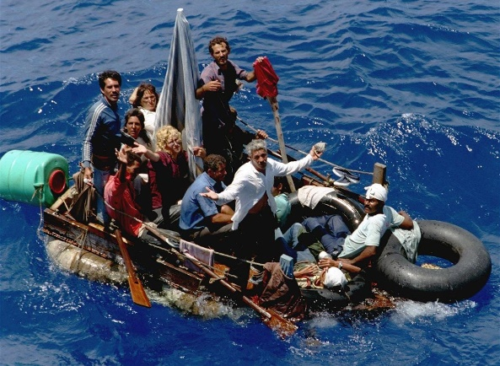
Mariel Boatlift, 1980
Left: From History.com, photo by Tim Chapman for the Miami Herald/Getty Images. In “The Mariel Boatlift: How Cold War Politics Drove Thousands of Cubans to Florida in 1980,” Karen Juanita Carrillo. Updated August 9, 2023, originally published September 28, 2020.


Right: From Medium.com, with a first hand account of Coast Guard Officer In “America, the Beautiful,” Ted Cheney. Uploaded November 27, 2016.

Saint Louis, 1939
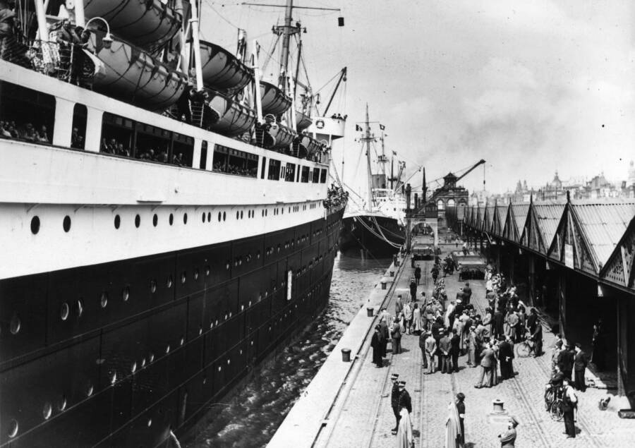
Left: From AllThatsInteresting.com, photo by Three Lions for Getty Images. In “The Harrowing Voyage Of The SS St. Louis, The Jewish Refugee Ship That No One Wanted On The Eve Of The Holocaust,” Austin Harvey. Updated September 29, 2022, originally published September 28, 2022.


Right: From BBC.com, photo by Bettman. In “Canada apologises for turning away Jewish refugee ship in 1939,” by unknown author. November 7, 2018.


Cuban Rafter Crisis, 1994

Left: From Wikipedia.com, photo by Andrew Smith. Titled “Balseros spotted and rescued by the Carnival Liberty in 2014,” subtitled “Taken on the Carnival Liberty in August 2014, Cuban refugees that built a raft and were rescued by the Carnival Liberty ship.” Uploaded February 14, 2015.

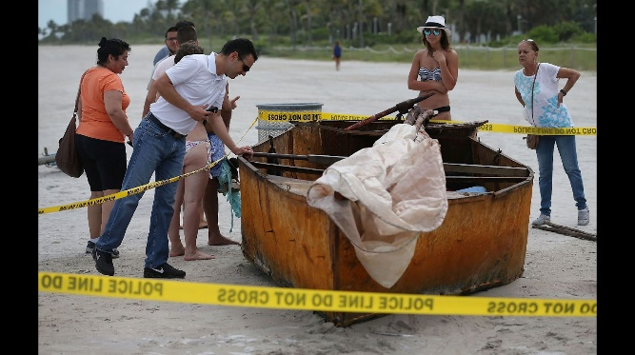

Right: From CNN.com, photo by Joe Raedle for Getty Images. “Cuban-Americans react to end of ‘wet foot, dry foot’ policy,” Marilia Brocchetto and Darran Simon. Updated January 13, 2017.

Timeline

Policy Breakdown:
- Chinese Exclusion Act of 1882
- Cuban Adjustment Act of 1966 (encompasses wet foot/dry foot)
- China’s one-child policy begins 1979
- Cuban/Haitian Entrant Act of 1980
- Immigration Reform and Control Act of 1986
- Matter of Chang BIA Decision 1989
- AG William Barr and POTUS H. W. Bush orders on persecution under one-child policy 1990
- China’s one-child policy ends 2015
Event Breakdown:
- Ellis Island: opens 1892
- Saint Louis departed May 1939
- Ellis Island: closes 1954
- Castro rises to power 1959
- Wave of Cuban Exodus: Mariel Boatlift 1980
- Matter of Chang BIA Decision 1989
- Golden Venture lands in New York City June 1993
- Wave of Cuban Exodus: Cuban Rafter Crisis 1994
- President Bill Clinton First State of the Union Address 1995
- President Bill Clinton Second State of the Union Address 1997
- Golden Venture passengers pardoned Feb. 1997
- TX Gov. Greg Abbott’s Operation Lone Star Dec. 2023
- FL Gov. Ron DeSantis’ Haitian migration policies March 2024

Sources in order of episode’s reference

“The New Colossus” by Emma Lazarus, accessed from the National Park Service, last updated August 14, 2019, https://www.nps.gov/stli/learn/historyculture/colossus.htm.
“1995 State of the Union Address,” accessed from Wikipedia courtesy of William J. Clinton Presidential Library, https://en.wikipedia.org/wiki/1995_State_of_the_Union_Address.
“Throwing Down the Ladder from Which They Rose,” political cartoon by Thomas Nash, July 23, 1870, Harper’s Weekly, accessed from Illustrating Chinese Exclusion on May 9, 2024, https://thomasnastcartoons.com/2015/01/06/throwing-down-the-ladder-by-which-they-rose-23-july-1870/.
Erin Blakemore, “A Ship of Jewish Refugees Was Refused U.S. Landing in 1939. This Was Their Fate,” June 4, 2019, https://www.history.com/news/wwii-jewish-refugee-ship-st-louis-1939.
Uriel J. Garcia, “Gov. Greg Abbott Signs Bill Making Illegal Immigration a State Crime,” Texas Tribune, December 18, 2023, https://www.texastribune.org/2023/12/18/texas-governor-abbott-bills-border-wall-illegal-entry-crime-sb3-sb4/#:~:text=Greg%20Abbott%20signs%20bill%20making.
Senate Resolution 258, June 20, 2023.
Rachel Siegel, Lauren Kaori Gurley, and Meryl Kornfield, “The economy is roaring. Immigration is a key reason,” Washington Post, February 27, 2024, accessed April 15, 2024, ProQuest, http://ezproxy.ycp.edu:8000/login?url=https://www.proquest.com/washingtonpost/blogs-podcasts-websites/economy-is-roaring-immigration-key-reason/docview/2932314444/sem-2?accountid=29140.
Greg Allen, “DeSantis is prepping for a wave of Haitian migrants. Advocates say he's grandstanding,” NPR, March 21, 2024, https://www.npr.org/2024/03/21/1239647148/haiti-florida-migrants-desantis-immigration.
Brian Naylor and Tamara Keith, “Kamala Harris Tells Guatemalans Not To Migrate To The United States,” NPR, updated June 7, 2021, accessed April 15, 2024, https://www.npr.org/2021/06/07/1004074139/harris-tells-guatemalans-not-to-migrate-to-the-united-states.
Barbara Sprunt, “Biden Would End Border Wall Construction, But Wouldn't Tear Down Trump's Additions,” NPR, August 5, 2020, accessed April 15, 2024, https://www.npr.org/2020/08/05/899266045/biden-would-end-border-wall-construction-but-wont-tear-down-trump-s-additions.
Juan A. Lozano, “Federal judge declares DACA illegal again, issue likely to be decided by Supreme Court,” Associated Press/PBS, September 13, 2023, accessed April 15, 2024, https://www.pbs.org/newshour/politics/federal-judge-declares-daca-illegal-again-issue-likely-to-be-decided-by-supreme-court#:~:text=The%20states%20have%20argued%20the,the%20federal%20Administrative%20Procedures%2Act.

